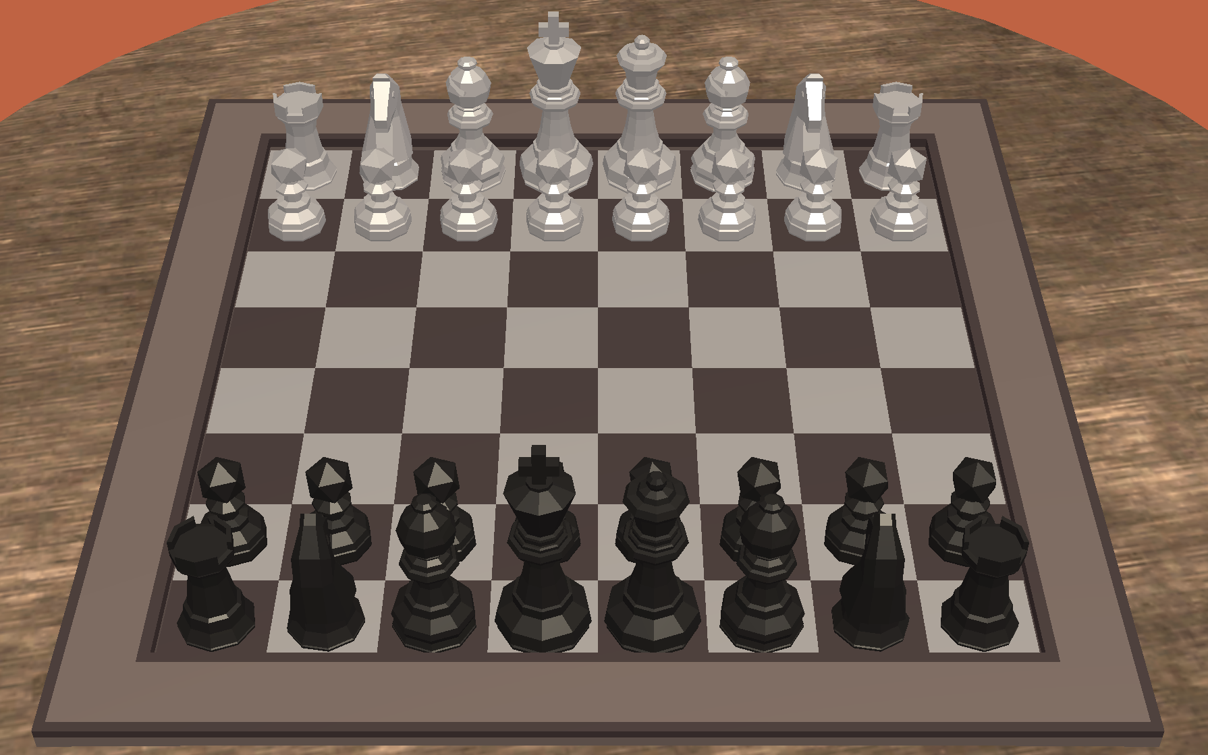
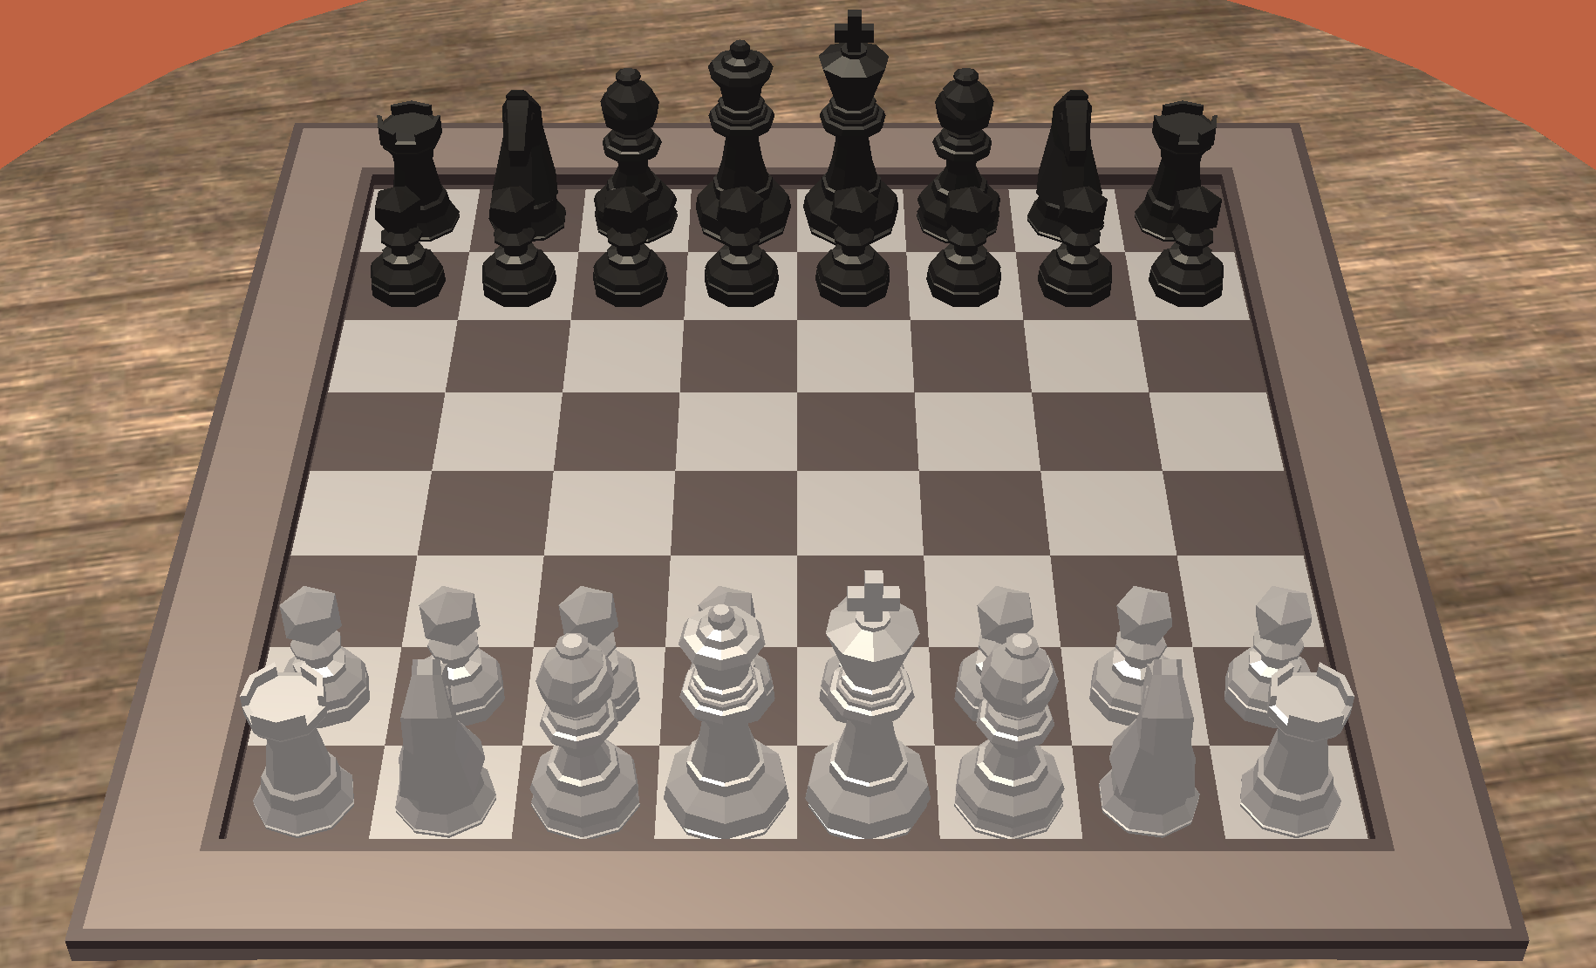

Chess Game Rules

OBJECTIVE: Checkmate (threaten with no escape options remaining) the opponent’s king.

SET UP: Chess is a two player game. The board is set up where each player has the light color square in the bottom right corner. Rooks are placed in the corners of the first row (the row closest to the player). Knights are placed immediately inside of the Rooks. Bishops are placed immediately inside of the Knights. The Queen is placed between the Bishops on the square matching her color. The king is placed next to the Queen. Pawns are placed in the 8 squares in the second row.

PLAYING: The player with the light pieces plays first. Players alternate moving one piece at a time. The only exception to this is castling (see terms below). A piece may be moved into any vacant location that is a valid move for the piece or “capture” the opponent’s piece by moving their piece into the opponent’s pieces square. The only exception to this is en passant (see terms below). The captured piece is removed from play. During the course of play if a player's piece threatens the opposing player's king then the opposing player's king is in “check”. On their turn the opposing player must move their king to a location that is not threatened, remove the piece that is threatening it or block the path from the threatening piece to the king. If a player’s king is in check and they are unable to make a move so that their king is safe then the king is checkmated. The checkmated player loses and the game is over.

PIECES AND MOVEMENT:
King - Move one square horizontally, vertically, or diagonally. Is also part of a special move called Castling.
Queen - Move any number of open squares diagonally, horizontally, or vertically.
Rook - Move any number of open squares vertically or horizontally.
Bishop - Move any number of open squares in any diagonal direction.
Knight - Moves one square horizontally or vertically then two squares horizontally or vertically OR two squares vertically or
horizontally and then one square horizontally or vertically. The second movement can not backtrack on the first
movement. Its movement is not blocked by other pieces. Is also part of a special move called Castling.
Pawn - During the first move off it’s starting spot, a pawn can move two squares vertically. In all other turns it can only
move one square vertically. Unlike its movement, when attacking with the pawn, a player must move forward
diagonally one square. A pawn is also able to make a special move called an en passant (see terms below). It can
also be promoted if it reaches the far row of the board.

TERMS:
- Check - A player’s piece is in “check” if their king is in danger of being captured by their opponent, but is able to move out of the path of the threatening piece or is able to block or capture the threatening piece.
- Checkmate - A player’s king is in “checkmate” if the king is unable to move to a location that it can not be captured or is unable to remove or block the piece or pieces that have placed it in check.
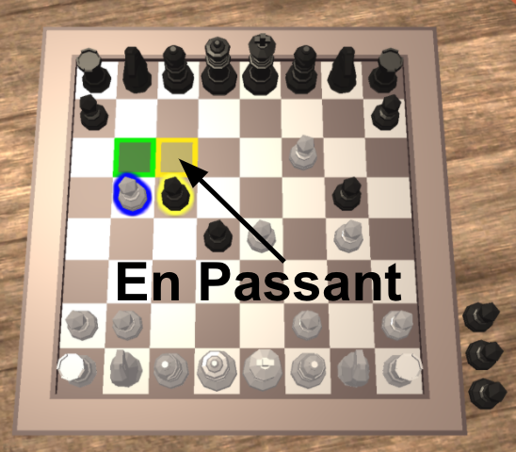
- Capturing - A player “takes” the opponent's piece, when the player’s piece lands on the square of the other’s player’s piece. The piece that was taken, is collected on the opponent’s side off the board.
- En Passant - This is when the pawn moves two squares during its first move and lands next to the opponent’s pawn (same row), the opponent may capture this pawn by moving diagonally to the space the pawn would have occupied had it only moved one space. See picture on the right for a visual of the white pawn capturing the black pawn using en passant.
- Castling - A move that includes the king and either rook. This is the only time two play pieces can move on one turn. In order to “Castle” 3 conditions must be met.
  - 1. It must be the first move for both the king and the rook.
  - 2. No other pieces can be between the king and the rook.
  - 3. The king can’t be in Check, either before or after the castle or on any spaces that it passes over. To castle move the king two squares towards the rook and then move the rook on the other side of the king.
How to Castle:
  - 1. Move the king next to the rook.
  - 2. Move the rook to the other side of the king.
- Pawn Promotion - If a player advances a pawn to the farthest row on the opposite end of the board, then the pawn can be promoted to a queen, bishop, rook or knight.
- Draw - A draw is where neither player wins. This can happen in several ways.
  - If a player’s king is NOT in check and they have no legal moves remaining
  - If the remaining pieces on the board can not result in a checkmate then the match is a draw:
    - King vs. King
    - King vs. King & Bishop
    - King vs. King & Knight
    - King & Bishop vs. King & Bishop with both Bishops of the same color.
- Stalemate - A player’s king is not in check, but any move will place them in it.
- Resign - A player may resign at any time in which case their opponent wins the game.

